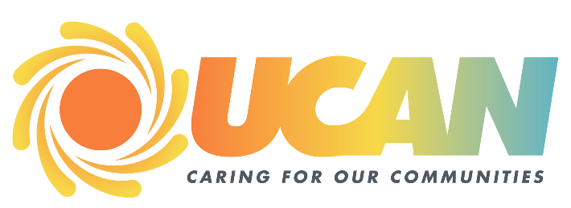***FOR IMMEDIATE RELEASE***

9/2/2025

Val Gordon

UCAN Food Bank

541 817 5132

[Valerie.gordon@ucancap.org](mailto:Valerie.gordon@ucancap.org)

[www.ucancap.org](http://www.ucancap.org)

**"Fill the Barrel – Feed the Community" UCAN Food Drive hosted by Colombia Bank and Sherm’s Thunderbird**

Roseburg Oregon –September Is Hunger Action Month and to raise awareness about hunger locally, Sherm’s Thunderbird, Columbia Bank (formerly Umpqua Bank) and the UCAN Food Bank are hosting the Fill the Barrel- Feed the Community Food Drive.

Support families facing food insecurity by collecting non-perishable food and raising awareness during Hunger Action Month.

September 1st, 2025 through September 30th 2025 Sherm’s shoppers can help fight hunger in their local community one of three ways:

* Round up at the register.
* Purchase products and place them in the UCAN Food Bank Barrels provided in the store.
* Donate online at: <https://ucancap.networkforgood.com/admin/projects/256589-stand-against-hunger-in-september>

On Wednesday September 10th from 10am to 6pm UCAN and Columbia Bank employees will be onsite at the store collecting food donations. All community members are encouraged to donate food or cans for our Bottle Drop account. Bottle Drop bags can be picked up the day of the food drive or at our warehouse located at: 284 Kenneth Ford Drive.

Donations of non-perishable, nutritious foods are especially needed. Food needed most includes canned meat, peanut butter (crunchy or creamy), cereal, canned vegetables, chili and hearty soups.

The UCAN Food Bank supports 15 emergency pantries, 3 community kitchens and various supplemental agency partners. Currently, around 12,000 residents visit a Douglas County emergency pantry each month, 25% of whom are children.

The Douglas County UCAN Food Bank is taking September to talk about hunger and inspire our community to take a stand. Every action – big or small – is one step closer to an America where no one is hungry. When people are fed, futures are nourished, and we can all reach our full potential. In 2025, 1 out of every 5 in Douglas County residents accessed emergency food services. States UCAN Food Bank Manager Val Gordon

UCAN is the local community action and a non-profit agency serving Douglas and Josephine County and is dedicated to enhancing prosperity and well-being throughout our communities. Our programs and services address critical issues such as housing and homelessness, food security, energy efficiency, child development, family well-being, and health. Our mission is simple yet profound: "Creating solutions to poverty, improving lives in our community." At UCAN, we envision a future where every resident we serve has access to the resources and opportunities necessary to realize their full social, civic, and economic potential. Our goal is to empower individuals to secure their lives and actively participate in building stronger communities. Learn more at [www.ucancap.org](http://www.ucancap.org).