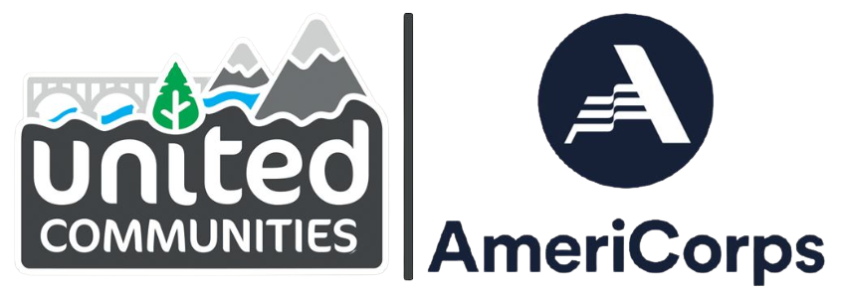

Position Description
United Communities AmeriCorps (UCA) members engage in meaningful service that meets critical community needs throughout Southwest Oregon. UCA projects improve access to social services by bridging barriers to educational opportunities, mentoring, job skills development, employment resources, family stability, and having healthy futures. Our members engage clients in their dedicated service project, and then use their experience to recruit, retain, and support community volunteers in their project and host site. Our positions are a dynamic combination of serving in a dedicated project (85%) and engaging in civic and professional development opportunities, alongside our AmeriCorps cohort (15%).

SERVICE TERM
August 28, 2024 – July 31, 2025 (Full-time; 11 months – 1700 hours)
MEMBER LIVING ALLOWANCE
$22,000 living allowance paid over the 11-month service term

EDUCATION AWARD
$7,395 Segal Education Award upon successful completion of the term of service
POSITION TITLE

PROJECT HOST SITE
|
PROJECT LOCATION

POSITION SUMMARY

ESSENTIAL RESPONSIBILITIES (to include, but not limited to)

- Implement and/or develop systems to inform Volunteer Management Goals.
- Complete and submit all necessary UCA paperwork and reports in a timely manner.
- Attend and complete all UCA training and service requirements including orientation, trainings, team meetings, and National Days of Service (Make a Difference Day, MLK Jr. Day, Cesar Chavez Day and a June Service Event).
- Wear AmeriCorps apparel and/or appropriate identifiers while performing service or attending official events.

MARGINAL RESPONSIBILITIES (to include, but not limited to)

POSITION REQUIREMENTS

- 17 years of age or older, at beginning of service term.
- U.S. citizen, U.S. national or lawful permanent resident.
- Possession of a high school diploma or equivalent, or commit to earning one prior to receiving an education award.
- Ability to commit to the full term of service for which they are applying.
- Must successfully pass a National Service Criminal History Check provided through UCAN and/or Project Host Site.
- Regular and reliable attendance.
- Have not previously served four terms in an AmeriCorps*State or National program. Members are only eligible for the equivalent of two full-time education awards in their lifetime.
- Applicants must disclose if they have ever been removed for cause from any national service program.

PREFERRED QUALIFICATIONS

SERVICE CONDITIONS

PHYSICAL & INTELLECTUAL DEMANDS

EQUIPMENT USED

TRANSPORTATION INFORMATION

MEMBER BENEFITS INCLUDE
- $22,000 living allowance paid over the 11-month service term (approx. $916.67 bi/weekly, before taxes).
- $7,395 education award upon successful completion of the term of service which can be used to repay qualified student loans or for further education in an accredited institution of higher learning, vocational or trade schools. The education award is taxed in the year that it is used. Members that are 55 and older may transfer the award to one child or grandchild.
- May be eligible for Loan Forbearance & Interest Accrual Repayment on qualified loans (after successful completion of a term of service, AmeriCorps will pay the accrued interest on qualified loans, which is taxable).
- Basic medical insurance (covers members only, not dependents; vision and dental not included).
- SNAP benefits for those who qualify.
- Child care allowance for those who qualify.
- Professional development, trainings and networking opportunities.

EQUITY & INCLUSION
UCA values diversity and seeks to provide an inclusive space that rejects intolerance. Qualified individuals with disabilities and those from diverse backgrounds are strongly encouraged to apply. UCA is an AA/EEO employer. UCA provides reasonable accommodations for qualified individuals and conducts all activities in fully accessible settings.

HOW TO APPLY
Application Deadline: July 31, 2024
Interviews are conducted on a rolling basis as qualified candidates are identified, so early application is strongly encouraged as member selection may be made prior to the application deadline.
Apply to United Communities AmeriCorps:
Option 1:
• Visit https://my.americorps.gov/ and select “apply to serve”
• Create a login and password
• Build your AmeriCorps profile and application to serve
• Click on “Advanced Opportunity Search” and search by Program Name: “UCA” and State: “OR”
Option 2:
• email the following documents to ucamericorps@ucancap.org
• Resume
• Cover Letter (1 page)
• Contact information for two References (name, title, relationship, email, & phone)
QUESTIONS ABOUT THIS POSITION? CONTACT:

|

|
QUESTIONS ABOUT AMERICORPS? CONTACT:
Erik Wood
Program Manager | United Communities AmeriCorps
251 NE Garden Valley Blvd Suite 205, Roseburg, OR 97470
541-492-3919 | erik.wood@ucancap.org

