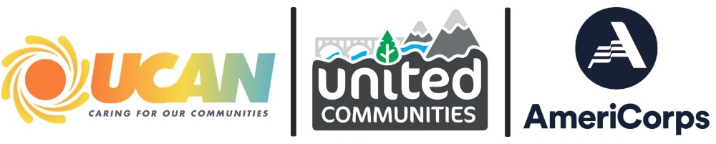
Application Checklist
Email Submission with following materials | Application Sections
 | Application Overview
 | - Coversheet
 | - Eligibility Information
 | - Executive Summary
 | - Project Narrative
 | - Position Description
 | Required Supporting Documents
 | - Certifications + Assurances Form (include a copy of your drug free workplace, workplace harassment & non-discrimination policies)
 | - Proof of eligibility: 501(c)(3) status, if applicable
 | - Copy of Organization’s Certificate of Insurance (includes single occurrence general liability, aggregate general liability, and auto coverage if applicable)

SUBMISSION
Submit an electronic copy by end of day on Wednesday, May 1st to meet our extended application deadline. Use the Application Checklist in the chart below to ensure all aspects of your application are completed. Late submissions will still be accepted, but applications submitted by the deadline will receive priority review.
- Download and review AmeriCorps RFP Guidelines
- Full Application: When you are ready to submit, email your application to ucamericorps@ucancap.org and Cc erik.wood@ucancap.org. Please include the following:
  - Completed application packet + Position Description
  - Signed copy of the Certification + Assurances form
  - Proof of 501(c)(3) status, if applicable.
Certificate of Insurance: email a copy of your organization’s certificate of insurance to UCAN’s Contract and Project Specialist, Howard Kopp, at howard.kopp@ucancap.org and Cc erik.wood@ucancap.org.

