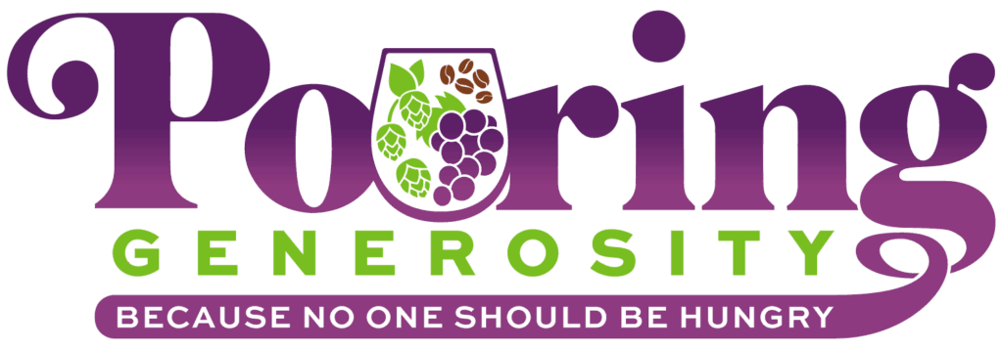**Participant List and Offerings**

**Wines:**

* **ABACELA**
  + *Donating a portion of wine bundles sold in July including: Albarino Private Selection 2023, Tempranillo Barrell Selection 2021, and Grenache 2021*
* **BRANDBORG VINEYARD & WINERY**
  + *100% of tasting fees this summer will be donated*
* **BRADLEY VINYARDS**
  + *$1 for every bottle of wine purchased in July*
* **COOPER RIDGE VINEYARD**
  + *Hosting a summer food drive*
* **FREED ESTATE WINERY**
  + *Donating proceeds from a wine raffle*
* **JOSEPHJANE WINERY**
  + *Donating a portion of all bottles sold in July*
* **KNOSTMAN FAMILY WINERY**
  + *Donating $1 of every bottle sold in July & August*
* **MELROSE VINYARDS**
  + A portion of each bottle of wine sold this summer
* **RICHWINE VINEYARDS**
  + A portion of each bottle of wine sold for the month of July
* **RIVERS EDGE WINERY**
  + *$1 for every bottle of wine purchased in July*
* **SEASON CELLARS**
  + *A portion of tasting room fees for July & August will be donated*
* **TRELLA VINEYARDS**
  + *Proceeds from Trivia night in July*
* **WHITETAIL RIDGE VINEYARD**
  + *$1 for every bottle of wine purchased this summer*

**Beers:**

* **BACKSIDE BREWING**
  + *A portion of proceeds from all sales of Dark Mexican Lager in July and August*
* **LOOKINGGLASS BREWERY**
  + *A portion of proceeds from all sales of Hoptime Pale Ale in July and August*
* **MCMENAMINS ROSEBURG STATION PUB & BREWERY**
  + *Every Tuesday $1 from pints and $2 from Growler fills of Tom’s Half Shell IPA*
* **NORTH FORTY BEER COMPANY**
  + *A portion of proceeds from all sales of Haze of Glory*
* **TWO-SHY BREWING**
  + *A portion of proceeds from all sales of Farmhouse Hazy Saison IPA*

**Other participants:**

* **BUMBLE & BEAN COFFEE**
  + *$1 of each coffee flight sold in July and August*
* **JAVA RUN**
  + *$1 from spring and summer menu items at all 3 Java Run locations*
* **OAKLAND COFEE CO**
  + *A portion of sales from Chai Latte, Iced Latte, Mocha Latte and Vanilla Latte in July and August*
* **THE ATOM BISTRO AND COFFEE BAR**
  + *Portion of sales from every charcuterie and two glasses of wine sold in July and August*